Name: Shakthivel R
Reg No: 192524325
Couse: Data Structures
Course Code: CSA0307
Date:24/07/2026
CO1-OUTPUT PREDICTION

1)Program to Find Missing Element in an Array

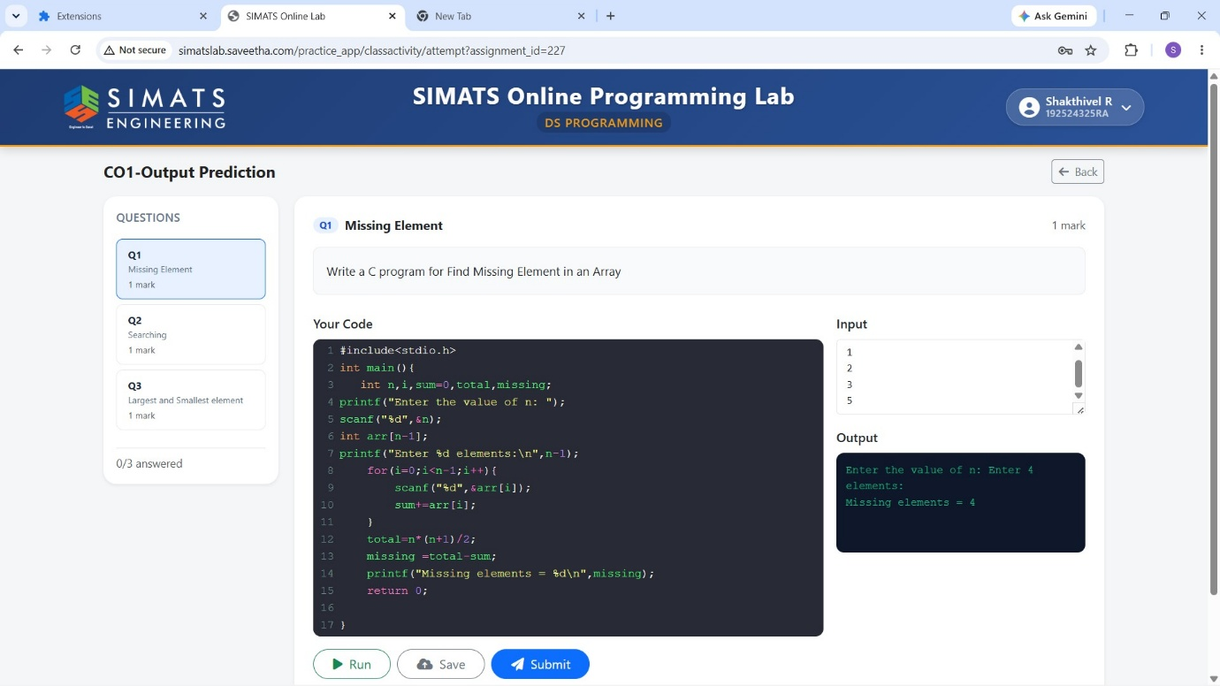

2) Program for Searching an Element in a Sorted Array

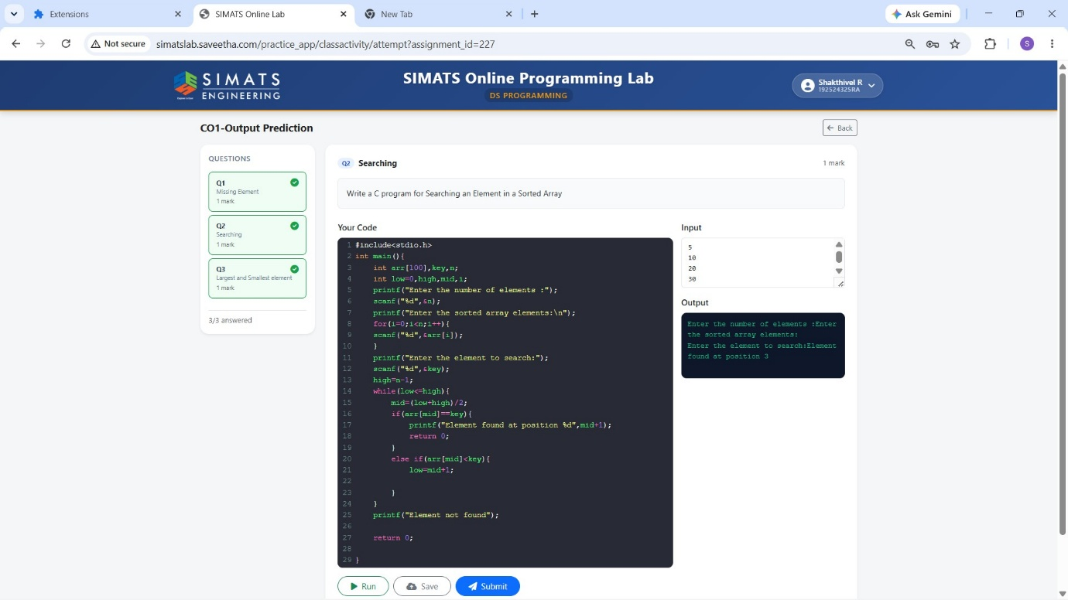

3) Program to Find the Largest and Smallest Element in an Array

